# GPS Data Acquisition

## Introduction

In addition to the geophysics data, you will also need to acquire accurate location data using an Emlid GPS with which you will be provided. These recievers gather data on latitude, longitude, and elevation with varying degrees of accuracy and precision, depending on the survey setup and post-processing that is applied to the data.

In order to use the Emlid GPS kits, you *must* have the Emlid Flow 360 app installed on the phone of at least one person in the group. The app can be downloaded through the following links:

* Android: <https://play.google.com/store/search?q=emlid%20flow%20360&c=apps>
* iPhone: <https://apps.apple.com/gb/app/emlid-flow/id1463967138>

Once the app is installed, and you are in the field with the GPS receiver turned (all three lights on the front should be solid – *not flashing* – this can take a while after turning them on) on follow these steps to take your measurements:

1. Once the GPS is turned on, you can connect to it on your phone by connecting to it like any other Wi-Fi network – you may need to turn off your internet data for this work.
   1. Make sure only to connect to the Wi-Fi network that match the unit number of *your* rover
   2. The password for all rovers is: **emlidreach**
2. Open the Emlid Flow 360 App and select the rover which you have connected to – you may need to click “Refresh” first in order to see it on the screen.

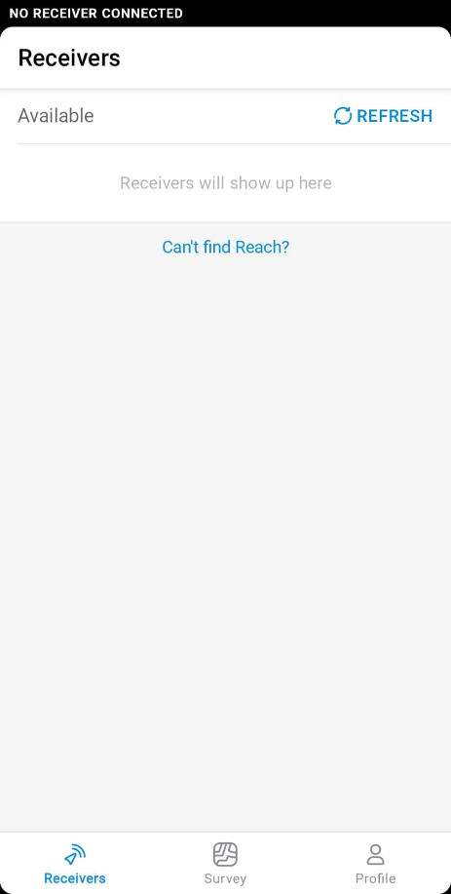

1. Select “Survey” at the bottom of the screen and create a new project by pressing the “+” sign in the top right corner.

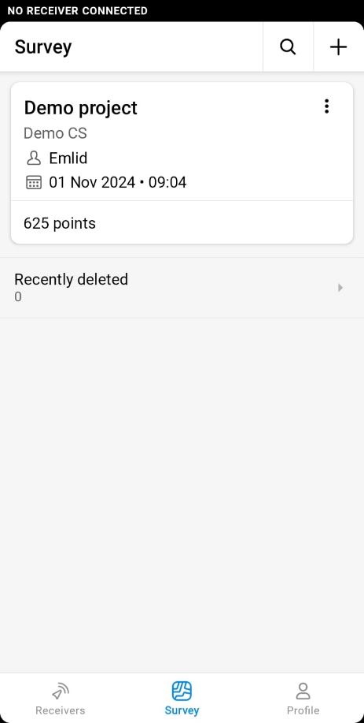

* 1. 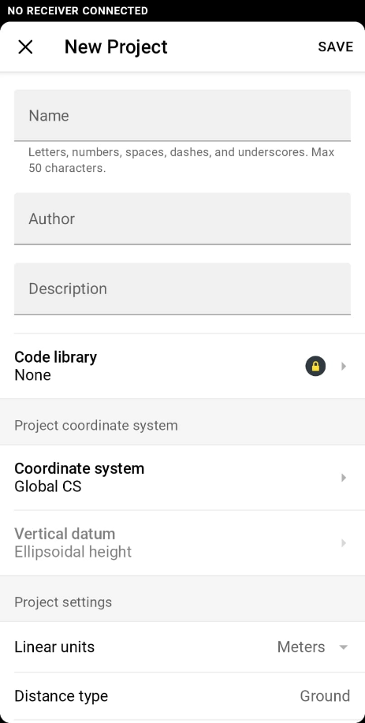Fill out all the relevant details for the project. Give it a sensible, and memorable name (and write this down in your notebook/on your proforma sheet)
  2. Leave all other info as defaults – you could change the Coordinate System if you wanted to, but we will leave it as “GlobalCS”, and the vertical datum as “ellipsoid” for now.

1. Once you have saved your project details you will be able to enter the project and start surveying. You will most likely see an empty map, with a small dot labelled “R” – this is the location of your GPS rover.
   1. New points will show up as their own dots on the screen as you create them (see the image below for the demo project example which is pre-loaded into the app)

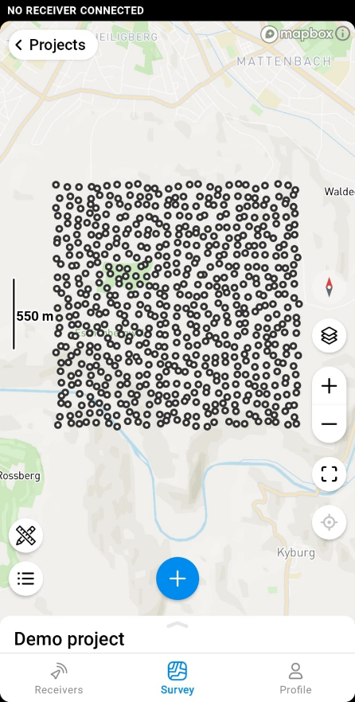

1. Check that the pole height is set to be whatever you have in the field – you can change this to whatever you like but make sure the pole and the app match.
   1. 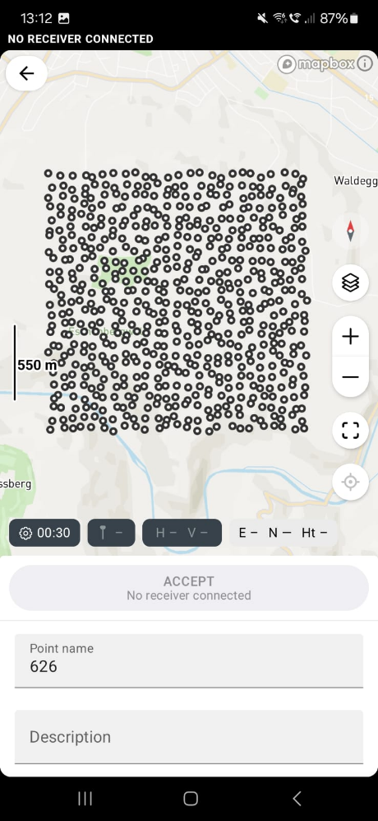Less than about 1.5m and the GPS will find it hard to see as many satellites as possible – *never* just hold it in your hand or place it on the ground to take a reading.
2. Check that you have the words “SINGLE” in red at the top right of the screen, if so then you are ready to take a point, if it says “NO SOLUTION” then the GPS cannot see any satellites
   1. In the latter case, move away from any tall buildings or tress, hold it upright and still on the end of the pole and it should resolve itself shortly.
   2. If you are using a Base Station, you should see the word “FIX” in green instead of “SINGLE” in red. If you don’t then you need to check the base connection.
3. Press the big blue “+” symbol to take a new reading, make sure to give the point a sensible name, and to write down this number against the relevant station number for your geophysical reading.
   1. 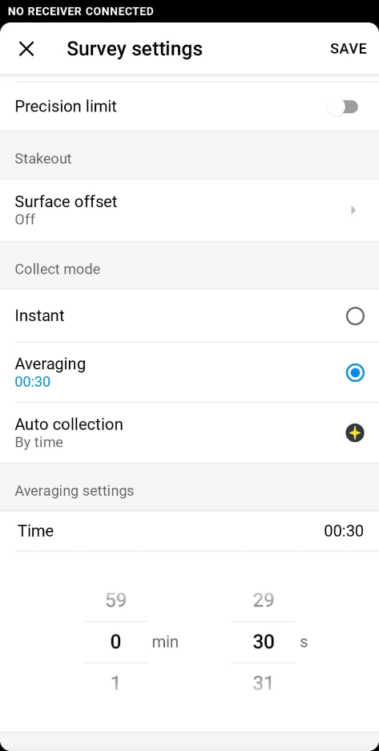Without a base station, it is usually sensible to leave this to “Average” for a few seconds, between 15 and 30 seconds is reasonable. You can alter this in the settings (the small cog symbol)

Once you have completed your survey and collected all of your GPS points, you will need to download your data from the app. It is best to do this in the field *immediately* so that you don’t forget. If you do forget it might be possible to recover the data at a later time, but if someone else uses the GPS before then it might be too late.

To download your data follow these steps:

1. Open the Emlid Flow 360 App and select “survey” at the bottom of the screen.
2. Navigate to the project you wish to export and select the three dots in the top right.
3. Select “Export” and choose and appropriate method and data format
   1. “.csv” is almost always the most appropriate format except in special circumstances
   2. 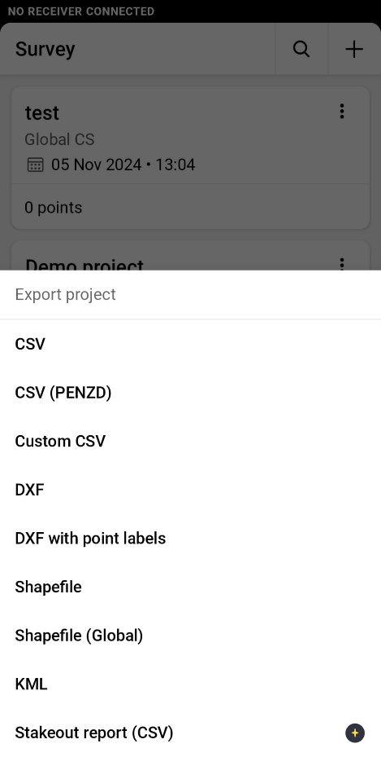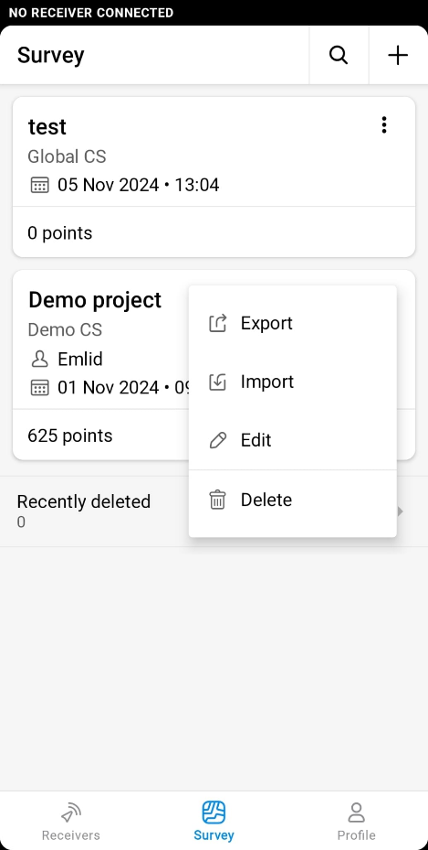It is usually easiest to download the data to your phone, and then email the results from your phone once you have an internet connection again (you can’t do this through the Wi-Fi connection of the rover itself)

A series of YouTube tutorial for using Emlid Flow 360 are available here:

Creating a survey project: <https://www.youtube.com/watch?v=tfSb_1yrYgY>

Collecting survey points: <https://www.youtube.com/watch?v=4tm3bJcf_wk>

Exporting your data: <https://www.youtube.com/watch?v=-X31SxMTd-o>